Calendly FAQ

Howdy Team,

It has been brought to our attention that there is some confusion about the new online booking system for lessons. Attached please find a step-by-step guide on how to register for your monthly lesson.

Each month, our website will be updated with the coach you are assigned to. For those unfamiliar with our website, you can see the monthly updated schedule here:

https://www.lssst.org/lesson-schedule

Underneath each coach’s name, you will find their unique Calendly link. Note: you do not have to sign up for this application to use it. If you are sent to a loading page, click “MonthX Lessons” – in this case, “March Lessons”. This feature will not be available much longer. When you click the link on the website, you will be sent directly to the monthly calendar seen below. That way, only those with the unique link can book a lesson.

From there, you will see a calendar that looks something like this:

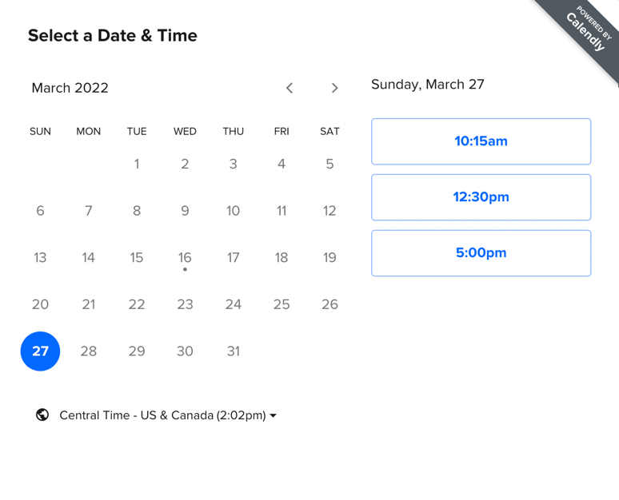

The highlighted days, in this case, the 27th, is the only remaining available day to book a lesson. I clicked on the 27th, and I am able to see a 10:15, 12:30, or 5:00 lesson available. This means that 10:15-12:15, 12:30-2:30, or 5:00-7:00 are all times that can be booked (remember that all lessons are 2 hours long, unless otherwise specified). Let’s say that I have availability at 12:30 on the 27th. I would click the 12:30 time on the right to book this time, and press “confirm”.

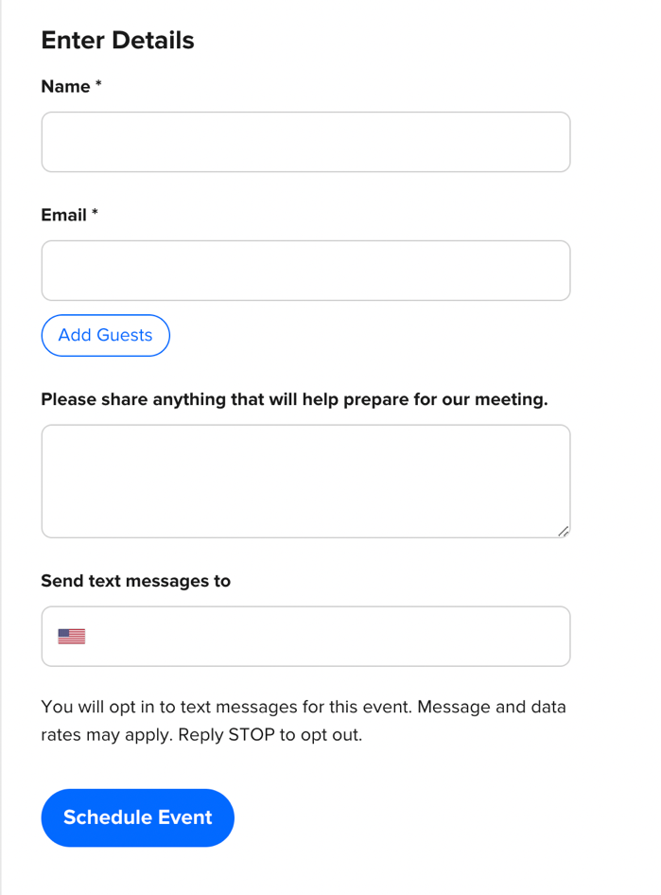

Next, you will be brought to this screen. All you have to do is fill out Name and Email. Please enter the student’s name in name section, and you can enter whatever email is easiest. If you would like text reminders, please enter your phone number where appropriate. If you would like to work on something specific-whether mental game, a certain technique, or have a question, you can enter it in the large text box. Once you hit schedule event, you will receive a email reminder as will the coach you have booked with. This automatically takes the time slot away from the Calendly schedule, and we can see we have you booked.

Please note, it is imperative you begin to look at the calendar early. If the month has passed, and you have not booked your lesson, you will not be allowed to reschedule. We have worked hard to provide times and days across the whole month, so it is your responsibility to book ahead of schedule. Also, there is no excuse for missing a lesson. You will now receive a email notification, and if you opt in, a text message notification. We are using this service to streamline efficiency and to ensure you get the most out of the coaching. Booking lessons typically takes several days of having to check our calendars and reach out to all of the students. Now, we are able to provide dates and times and have you choose a lesson that works best for you at your earliest convenience.

For any other questions, please reach out to Coach Meagan at (361) 558-0879. At some point, we will have all of the coaches using this platform. Please be patient while we get set up online to a new system.

